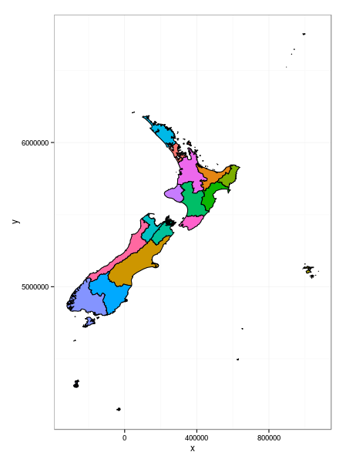

Map of New Zealand split into regional councils:

North Island:

* Northland
* Auckland
* Waikato
* Bay of Plenty
* Gisborne
* Hawke’s Bay
* Taranaki
* Manawatu-Wanganui
* Wellington

South Island:

* Tasman/Nelson (nelson region is tiny)
* Marlborough
* West Coast
* Canterbury
* Otago
* Southland/Stewart Island

Potentially Chatham Islands

Each region will act as a button/hyperlink. Potential ideas can be depression, anxiety, suicide etc. rates amongst adults, young adults and children in NZ; ethnicity if possible

I expect that I will have links on the side of the page, which can narrow data down to the various variables: age, ethnicity, gender, if I can find these facts.

<https://coronialservices.justice.govt.nz/suicide/annual-suicide-statistics-since-2011/>